IT 511: Object Oriented Application Development
Module Three: Data Types and Variables
ZyBooks: Programming in Java: Early Objects
Chapter 5
4/4/22

Learning Objectives

- Identify and apply primitive and non-primitive data types suitable for specific programming contexts
- Develop more complex data types from primitive types to address programming problems

Textbook Sections

Chapter 5: Data Types
- 5.1 Constant Variables
- 5.2 Math Methods
- 5.3 Type Conversions (Optional)
- 5.4 Binary (Optional)
- 5.5 Characters (Optional)
- 5.6 String Basics
- 5.7 Integer Overflow (Optional)
- 5.8 Numeric Data Types
- 5.9 Random Numbers (Optional)
- 5.10 Java Example: Married Couple Names with Variables

Module Overview

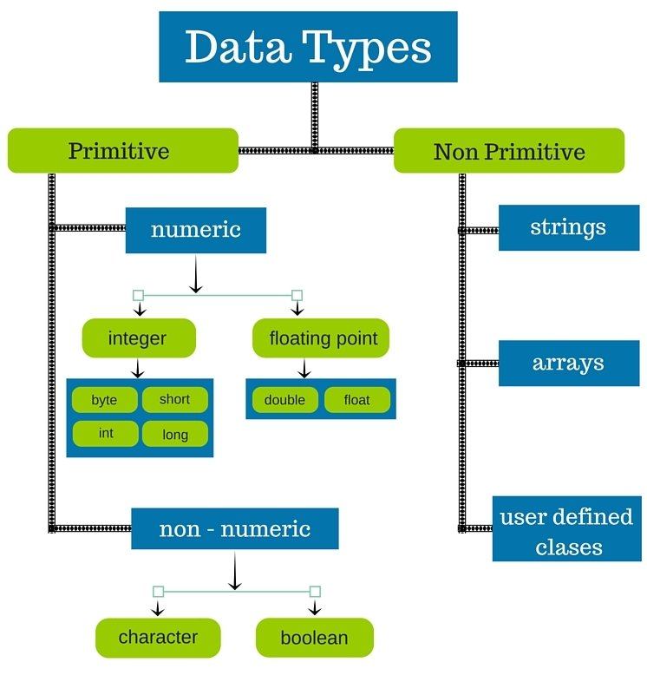
Image 3.1: Data-Type Graphic
(Image source: Merit Campus)
Common data types in the Java object-oriented programming language

Image 3.2: Tools Graphic
(Image source: 123RF)
Data types constitute a powerful set of tools for crafting, assembling, and at times even repairing programs.
Do you know someone who is good at fixing things? It may be your uncle, your mother, or a neighbor who tinkers in the garage at night. Perhaps you consider yourself rather handy and are curious about how objects work. In many cases, people who are good at fixing things or “mechanically inclined” are also fascinated by and comfortable using tools. Some have large collections of tools and select just the right one for any job. Others may like to test the flexibility of favorite tools and use them for many different jobs. As an aspiring object-oriented programmer, you also need to build your collection of tools as well as develop your ability to select and use these tools effectively. For object-oriented programmers, data types are a key set of tools. They range from basic types that are often referred to as “primitive” (think of a hammer or mallet) to more complex structures with considerable power. As you build your knowledge beyond this course, you will find that the collection of available data types in object-oriented programming is vast and expanding; it is a formidable toolset that represents the work of myriad IT professionals throughout the course of time.
In Module Three, you will focus on data types. These may include numeric types such as ints or data types defined by characters or Boolean logic. You will also begin the study of strings by working with the basic definition of strings as an ordered sequence of characters. This material builds on earlier modules; as you will see, data types help in defining objects and classes in a manner that prepares data for action. You will again complete the interactive materials in the zyBooks resource. As you are probably noticing, it is wise to work through this material with care at a deliberate pace and make sure that you have mastered simpler concepts before taking on more complex ones. Think of this as you would think of practicing a new skill such as skiing, needlepoint, or playing a musical instrument; master the basics, then move on to the more difficult maneuvers.
In this module, you will also complete the second stepping stone lab for the course. In this lab, you will work with data types, beginning with primitive data types and then moving up the ladder of complexity to strings and arrays. This is a great opportunity to see how well-defined, simple data types can make it easier to create the structures used to solve more challenging problems. This is a good time, too, to begin asking yourself when and why certain data types are useful. This will help you select the right tools as you begin to address the problems that object-oriented programming is meant to solve.

